**1**

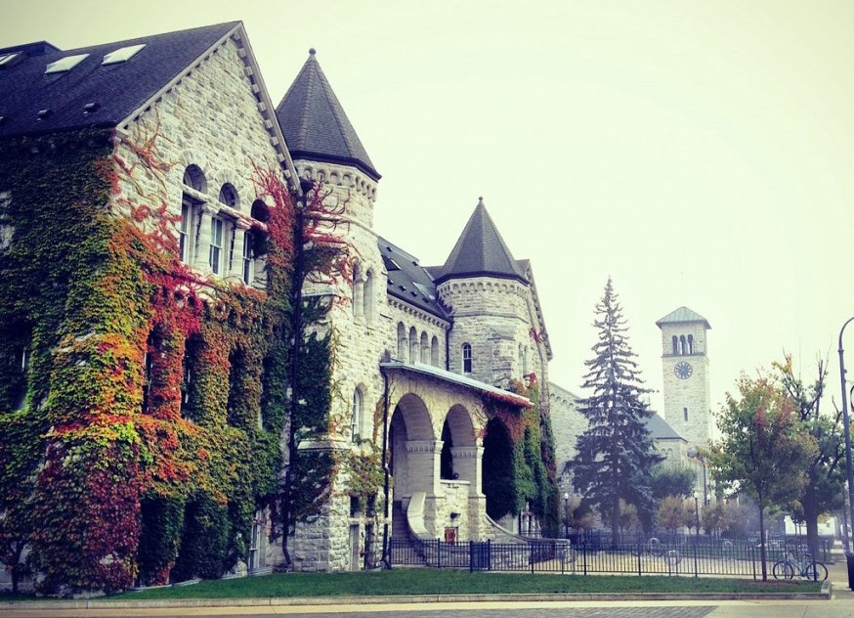

  



====================================================================

**Queen’s Global**

**Innovation**

**Conference 2014**

**Speaker Package**

====================================================================

###### What is the Queen’s Global Innovation Conference?

The Queen’s Global Innovation Conference (QGIC) inspires delegates to care about the most pressing global issues of our time, to innovate solutions to these issues, and to integrate the solutions into their communities. QGIC aims to attract students with different backgrounds to provide a variety of perspec- tives for the problem solving process. We want to challenge delegates to ask questions about themselves and the systems they operate within. The conference will be taking place November 14th & 15th 2014.

###### Our Vision

The Queen’s Global Innovation Conference, or QGIC, is proud to be the most interdisciplinary conference at Queen’s. We believe that a culture of innovation and a new approach to problem solving are necessary as we challenge the increasingly complex global problems of today. We will explore the large issues such as health care, food production, and poverty, with a focus on the role of technology within these systems. QGIC is designed to teach, inspire, and serve as a catalyst for delegate innovations. We are founded on the belief that great ideas are not born from epiphany but rather from an ever colliding network of thoughts, questions, and perspectives. It is from these collisions that innovations are born. Delegates will participate in speaker presentations and workshops, and then apply their skills within a team in the Innovation Chal- lenge. A participant driven conference, delegates will leave with the tools to innovate, lead, and inspire in order to join the movements that are changing the world.

### 1

###### 1. Collaborative Innovation

*“We are often better served by connecting ideas than we are by protecting them... Environments that build walls around good ideas tend to be less innovative in the long run than more open-end- ed environments. Good ideas may not want to be free, but they want to connect, fuse, recombine.... They want to complete each other as much as they want to compete”* - Steven Johnson

No one person holds the solution. Solutions will come from the experiences, insights and creativity of a group of individuals working together toward a common goal. Solutions will require coordination across industries, sectors, disciplines, and silos.

1. Systems Thinking

*“We can’t impose our will on a system. We can listen to what the system tells us, and discover how its properties and our values can work together to bring forth something much better than could ever be produced by our will alone.”* - Donella H. Meadows

The challenges we face are increasingly complex and interconnected. Complexity is the nature and con- dition of living systems and the world we live in. Systems thinking teach us to work within a system’s constraints to achieve desired results and avoid unintended consequences. It emphasizes wholes rather than parts, and stresses the role of interconnections—including the role we play within the system.

1. Leadership

*“Never doubt that a small group of thoughtful, concerned citizens can change world. Indeed it is the only thing that ever has.”* - Margaret Mead

Delegates should leave the conference feeling empowered to take action, and equipped with the necessary tools to accomplish their goals. We want to challenge delegates to ask questions about themselves and the systems they operate within, and to be leaders in their communities.

### 2



**The conference’s goals will be accomplished through the following venues:**

Speakers

Speakers will cover topics including health care, food production, and poverty and the technological in- novations within them.

Workshops

Delegates will choose between various workshops, focused on innovation, personal development, leader- ship, and global issues. Run by Queen’s clubs (QPID, EWB, WEAO, and more), and Queen’s staff and faculty these workshops will apply collaborative convening to problem solving.

The Innovation Challenge

The most hands-on part of the conference will take the form of a Dragon’s Den-style Innovation Chal- lenge. Delegates will work in inter-disciplinary teams to design a solution to a problem facing the Kings- ton area. A panel of judges will decide which group receives $1000 to put their plan into action. Funding for the challenge is provided by Queen’s Innovation Connector. The winning team is also eligible to pres- ent to the City of Kingston climate change panel.

### 3



Queen’s Global Innovation Conference aims to be the most interdisciplinary confer- ence at Queen’s. We want to get as many perspectives into the room as possible, and will be welcoming delegates from programs such as Engineering, Commerce, Eco- nomics, Global Development Studies, Political Science, and more. Undergraduate and graduate students will constitute the majority of the delegate base.

**4**

**Recommendations for a Good Presentation**

**General reminders:**

* **Audience:** Your talk should be directed at a smart general audience mainly composed of Queen’s students from all programs and Kingston community members.
* **Timed Rehearsal:** Your talk should not exceed 45 minutes out of respect for other speakers.
* **Theme of *The Power to Change Systems*:** Please make a point to relate your talk back to our conference theme as explained above.

**Tips for a strong accompanying visual aspect:**

* **Less is more:** A single, strong, graphic image or succinct line of text will tell your story better than a crowded collage or packed paragraph. Remember, people need to process everything you're saying while simultaneously absorbing your slides. Rather than one complex slide, show several slides, each with one idea, image or data point. Eliminate "headline and bullet-points" slides; they are tiring to read.
* **Presentation:** PowerPoint presentation is the standard, Prezi success contingent on internet connection.
* **Text quantity:** You rarely need more than six lines of text on a slide. Often, only a line or two will do. Sans-serif fonts (like Helvetica) are easier to read at a distance than serif fonts (like Times New Roman).
* **Slide background:** A simple background keeps your text readable. If you are using a dark or black background, make the text bold.
* **Graphs, graphics and photos:** Use visually arresting images, data and large words to serve as a mnemonic device so the audience has higher visual recall. Use high-resolution pictures and graphics. Full-quality photos.
* **Presentation assistance:** If you require help to design your slideshow or would like feedback on your speech, please email qgicspeakers@gmail.com.

**At the conference:**

* **At the event:** Speakers will sit in the audience and enter the stage from the audience. They are encouraged to stay for the whole event, and to mingle during breaks.
* **During the talk:** The talk must not go over the allotted time (not longer than an hour). We will cue you when your time has run out.
* **After the talk:** Speakers are encouraged to remain at the event throughout the day; at minimum, they're expected to stay through the conversation break following their talk, so attendees can approach them and ask questions.

**5**

**What makes a good talk?**

Here are some tips as you prepare for your talk. They will help you have a profound impact on your audience.

1. **Dream big.** Strive to create the best talk you have ever given. Reveal something never seen before. Do something the audience will remember forever. Share an idea that could change the world.
2. **Show us the real you.** Share your passions, your dreams ... and also your fears. Be vulnerable. Speak of failure as well as success.
3. **Make the complex plain.** Don't try to dazzle intellectually. Don't speak in abstractions. Explain! Give examples. Tell stories. Be specific.
4. **Connect with people's emotions.** Make us laugh! Make us cry!
5. **Don't flaunt your ego.** Don't boast. It's the surest way to switch everyone off.
6. **No selling from the stage!** Unless we have specifically asked you to, do not talk about your company or organization, pitch your products or services, or ask for funding from stage.
7. **Feel free to comment on other speakers' talks**, to praise or to criticize. Controversy energizes! Enthusiastic endorsement is powerful!
8. **Don't read your talk.** Notes are fine. But if the choice is between reading or rambling, then read!
9. **End your talk on time.** Doing otherwise is to steal time from the people that follow you.
10. **Rehearse your talk** in front of a trusted friend ... for timing, for clarity, for impact.
11. **Move us to action.** Awareness is the prerequisite for informed action, but it’s not an end in itself. Beyond awareness, how do you get your audience to care about your cause? How do you get them ready to take action, and to share their commitment with others?

**6**

**Presentation Outline Form**

|  |
| --- |
| Speaker Name: |
| Email: |
| Phone: |

[ ] Full presentation (45 minutes + 15 minutes for questions)

**Title of Talk:**

Brief summary of talk (to be published online):

What programs or software will you be using for your visual aid?

Would you like assistance from a Speaker Relations Team Member to help you:

[ ] Develop your slideshow/visual aid [ ] Provide guidance with writing your speech

Will you be requiring special equipment, props, or arrangements? Please describe your request below. We will try to accommodate everyone as best we can.

**7**

**Travel and Accommodation**

Due to limited sponsorship we are unable to guarantee every speaker sponsored travel and accommodations. However, we will try our best to accommodate as many of the expenses incurred by speakers as we can. The form below will help our Sponsorship Team with seeking funds to support your travel and/or accommodation, if necessary.

**Section 1: Require Travel and/or Accommodation**

*If you do NOT require travel and accommodation sponsorship, please proceed to Section 2.

|  |
| --- |
| Origin of Travel: |
| Do you require:  [ ] Accommodation in Kingston [ ] Transportation – Round Trip [ ] Transportation – One Way |
| Would you like to be a part of our carpool list (Y/N)? |
| Available to arrive on _______________________ at:  [ ] Morning [ ] Afternoon [ ] Evening [ ] Other (please specify time: ___________________________) |

**Section 2: Do not require Travel**

Your travel plans:

[ ] Not applicable (ie. Live in Kingston) [ ] Personal Vehicle [ ] Bus/Train

If you are taking the bus or train, please provide your basic travel itinerary (ie. time of arrival) in the space below:

|  |
| --- |
| **Do we have your permission to share your contact information with other speakers from your area in order to coordinate a carpool program to Kingston (Y/N)?** |
| Preferred contact information: |

**8**

Please do not hesitate to contact us for more information, or to discuss any questions or concerns that you may have. We hope that we can work together to create positive change in our community and the world at large.

**Elena Vorvis**

**QGIC 2014 Speaker Coordinator**

Mechanical Engineering, Queen’s University

**E-mail: qgicspeakers@gmail.com**

**Adam Joe**

**QGIC 2014 Chair**

Mechanical engineering, Queen’s University **Phone: 613 252 5272**

#### Email: [adam.joe](mailto:11aej6@queensu.ca)[@queensu.ca](mailto:1aej6@queensu.ca)



**9**